**Short answer type questions**

**Q.1 What is electron affinity?**

**Ans.**

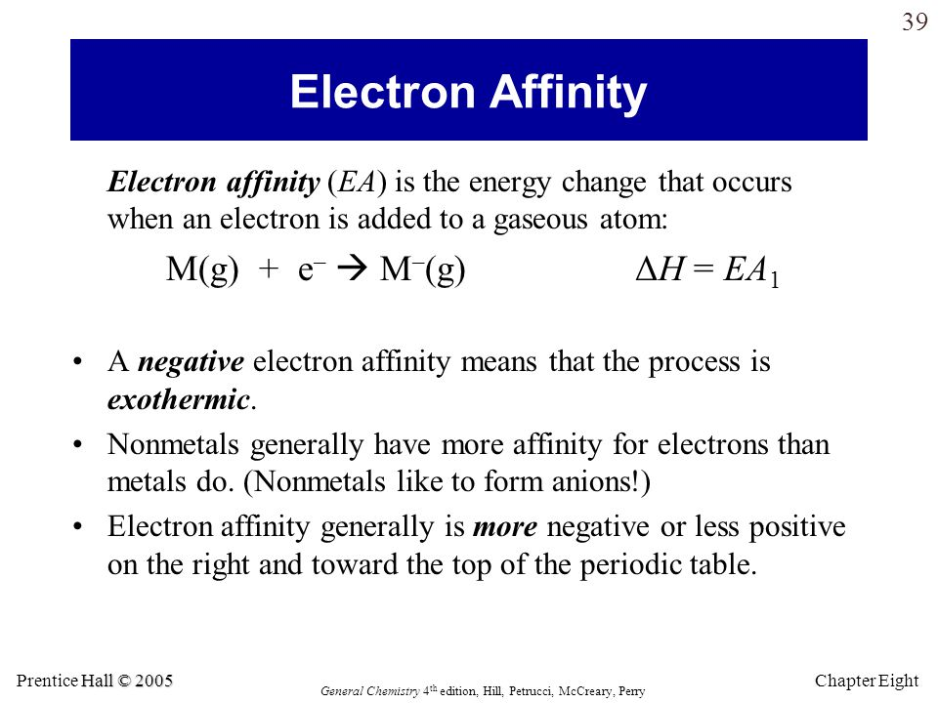.

**Q.2 How Atomic radius Affects the Magnitude of Electron Affinity**

**Ans. Atomic radius (r):** *Larger the atomic radius*, lesser the tendency of the atom to attract the

additional electron towards itself, due to lesser the force of attraction exerted by the nucleus on theextra electron being added to the valence-shell of the atom and hence *lesser the amount of energyreleased* when the extra electron is added to the atom to form an anion. Thus smaller atoms havehigher electron affinities. r α1EA

**Q.3 What is the Variation of electron affinity**

**Ans. (a) In a group:** EA depends on atomic radius **(r)**. As we sere seen r α1EA i.e. smaller the radius of the atom larger the EA and vice versa.Atomic ***radius increases*** down the group from top to bottom. Hence EA ***decreases in group from*** ***top to bottom*.**

**(b) In a period:** Atomic ***radius decreases*** from left to right of the period. Hence EA ***increases in***

***period from left to right of the period*.**

Q.4 **Why noble gases are having Zero electron affinity**

Ans.Noble gases are having zero electron affinity due to the Complete octet and their stable nature.

**Home Work**

**Q. What are the factors affecting Electron affinity?Explain in detail**